Use-Case Realization Report (Analysis)
Display Question Info

Issue 1.0
Revision History
Date | Issue | Description | Author
01/Aug/09 | 1.0 | First Issue | Thomas Yap

Table of Contents
1. Brief Description 4
2. Flow of Events 4
2.1 Standard Flow 4
2.1.1 Display Question Info 4
2.2 Exception 4
3. Interaction Diagrams 5
3.1 Collaboration Diagram for Display Question Info 5
4. Participating Objects 5
5. Class Diagrams 7
5.1 Class Diagram for Display Question Info 7
6. Derived Requirements 7

Use-Case Realization Report
Display Question Info

Brief Description
This use case enables the controller to display question info retrieve from Question Pool. It involves displaying the menu and form and search by searchstrings.

Flow of Events
The standard flow of events for this use case and any exceptions are described in the following subsections. The events are described in terms of Actors and Analysis Objects.

Standard Flow
This use case covers the Question Maintenance - Display Question Info. The standard flow of these events are described below.

Display Question Info
The running of the application is shown in section 3.1. The flow of event is as follow:

- When the application start, the first operation to be performed is the startup operation of the main controller. This operation will create all the control objects and the entity objects necessary for operation Update Question:
  - The control object created is: Question Controller
  - The entity objects create are: Question and Transaction Record

- The main controller will start the main function menu:
  - To start Display Question Info, operation FormDisplayQuestion is activated by Question Controller to display a Question form.
  - Portal Admin then input searchstrings for searching the record. The searchstrings can be the Question ID and Question Name.
  - Operation validate will validate the format of the entries.
  - Then Question Controller will check for additional criteria if any.
  - If no record found, Question Controller will send a error message to FormDisplayQuestion Interface.
  - After the record is found and display on FormDisplayQuestion.
  - A transaction log will be created by operation createActivity and store in entity TransactionRecord.

- Step 2 will be repeated until all searches are completed. Then controller will terminate the application by issuing operation close.

Exception
None.

Interaction Diagrams

Collaboration Diagram for Display Question Info
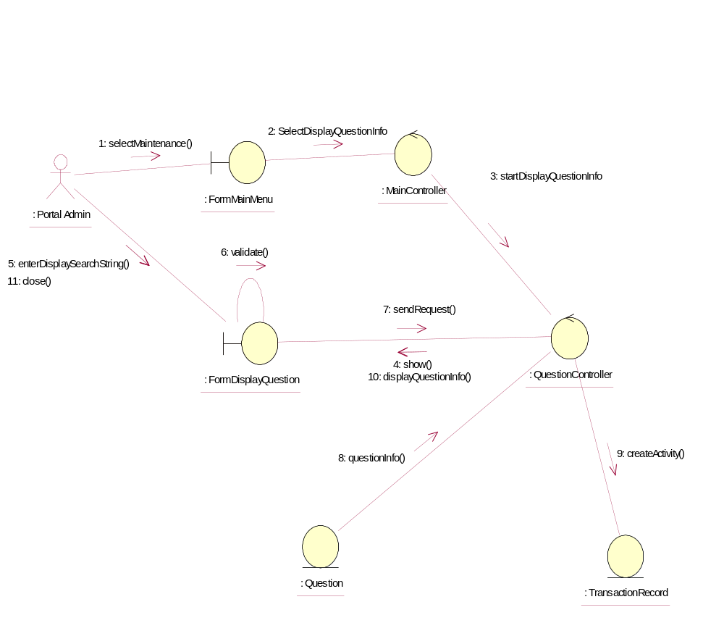

Participating Objects
: FormAddQuestion
This object is the interface for keying questions details.

: FormMainMenu
This is the main menu at the beginning of the application from where it can access the Question Maintenance - Display Question Info operation.

: MainController
This is the main controller that control the whole system.

: Portal Admin
This is the only actor that authorized to perform operation Question Maintenance - Display Question Info.

: Question
This entity stores all the exam or exercise questions.

: QuestionController
This is the controller for Question Maintenance. It creates and activates FormDisplayQuestion interface and Question entity object.

: TransactionRecord
This is the entity object that created for transaction log and audit trail.

Class Diagrams

Class Diagram for Display Question Info
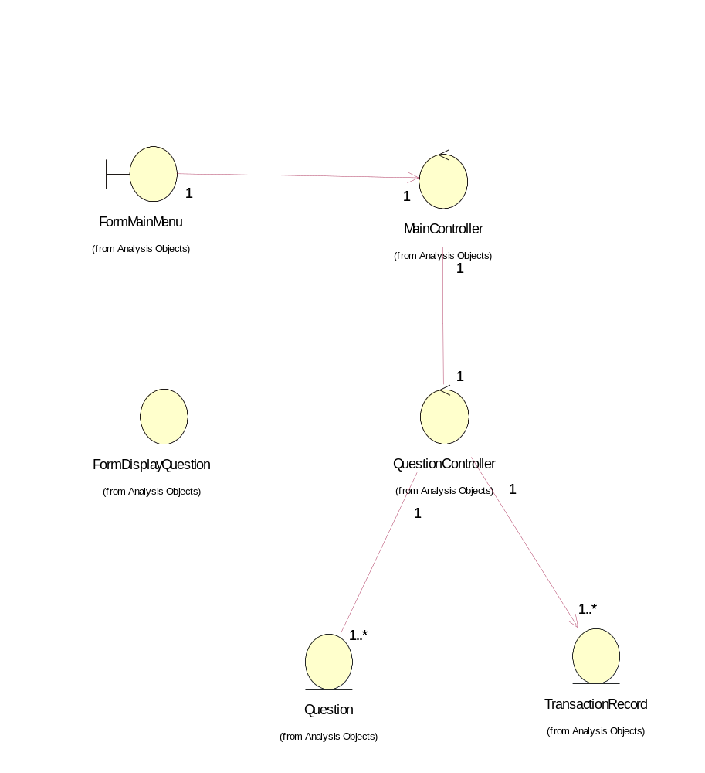

Derived Requirements
The FormMainMenu and FormDisplayQuestion Interface should have the format specified in User Requirements Specification for Content Management Portal.

